Digital Platform Deployment Guide



Microsoft Sports Platform

Prepared for

[Type Customer Name Here]

9/25/2017

Version 5.0 Draft

Prepared by

**Gabo Gilabert, Danny Garber**

Contributors

**Luis Javier Fernandez Jaraba, Cristofer Gonzales**

Revision and Signoff Sheet

Change Record

|  |  |  |  |
| --- | --- | --- | --- |
| Date | Author | Version | Change Reference |
|  |  | 0.1 | Initial draft for review/discussion |
| 08/11/2016 | Gabo Gilabert, Danny Garber | 4.0 | Updated for the Sports IP MDP 4.0 release |
| 12/22/2016 | Srinivasan Rakhunathan | 4.5 | Updated for the Sports IP MDP 4.5 Release |
| 09/25/2017 | Laxmikant Naik | 5.0 | Updated for Sports IP MDP 5.0 R2 Release |

Reviewers

|  |  |  |  |
| --- | --- | --- | --- |
| Name | Version Approved | Position | Date |
|  |  |  |  |
|  |  |  |  |
|  |  |  |  |

Table of Contents

1 Deployment Summary 7

1.1 Purpose 7

1.2 Content 7

1.3 Intended Audience 7

2 Deployment Scope 9

2.1 Deployment Topology 9

2.2 Components 10

3 Installation Strategy 13

4 Deployment Resources 14

5 Azure AD tenants and Apps 15

5.1 Azure AD Admin tenant 15

5.2 Assigning users and groups to application roles 16

5.3 Azure AD B2C Fans tenant 17

6 Digital Platform Build 23

6.1 Preparing 23

6.2 Compilation 23

6.3 Verification 23

7 Azure Setup Process 25

7.1 Preparing 25

7.2 Resources Provisioning 27

7.2.1 Scripted Resource Provisioning 27

7.2.2 Manual Resource Provisioning 29

8 Environment Configuration Files 30

8.1 Resources Configuration 30

8.2 Common Configuration 31

8.3 Deployment configuration. 36

9 Master Data Provisioning 38

10 Release Deployment 39

11 Data Provisioning 41

11.1 Application Data 41

11.2 Team Statistics 41

11.3 Application Resources 42

12 Appendix A: Application Role Definition 43

13 Appendix B: Parameter file tokens 44

14 Appendix C: How to enable Implicit flow 47

15 Appendix D: Exporting certificate with private key 48

1. Deployment Summary
   1. Purpose

The purpose of this document is to describe the process used to deploy the Azure-hosted components of the Digital Platform that is part of the Microsoft Sports Platform.

This document begins describing the topology and components to be deployed and then proceeds to describe the deployment process in detail.

* 1. Content

The document is composed of the following sections.

* **Summary**: This section contains a brief description of the purpose and provides the context of the document. It also provides an overall summary of the contents of this document.
* **Deployment Scope**: This section includes a high-level description of the environment that will be created as a result of following the process in this document.
* **Installation Strategy**: This section provides a summary of the decisions and conventions used while developing the deployment process.
* **Deployment Resources**: This section contains a list of the resources you will need to run the deployment process.
* **Digital Platform Build:** This section contains guidelines on how to build/compile the Digital Platform before running a deployment. This information is included for developers interested in deploying their own environment of the Digital Platform.
* **Azure Setup Process:** This section describes the process that operators will need to deploy the Azure environment where the solution will run. This process will only be run when the topology of the solution changes.
* **Release Deployment:** This section describes the process to be followed when a new version of the application or configuration needs to be deployed. It only updates the application, and does not change the general environment or its topology.
  1. Intended Audience

The document is intended for operators, testers, and developers responsible for deploying the solution, and for service managers in charge of operating it.

This document may also be helpful to architects and product managers looking to better understand the deployment of the solution.

1. Deployment Scope

This document provides guidance to install the pieces of the Digital Platform hosted in Azure, not including the Analytics Platform.

* 1. Deployment Topology

The environment created will have four deployments, as described in the document **Physical Design.** These deployments will be in the following Azure regions:

Update the table based on the locations and availability of your deployment

|  |  |
| --- | --- |
| Deployment Region | Audience |
| US West | This will target the main group of Fans and administrative users. |
| US East | This will cover remote local users and will also provide administrative function. |
| West Europe | Focused on European markets, no administrative capabilities will be deployed in this deployment. |
| Japan West | Focused on Asian markets, no administrative capabilities will be deployed in this deployment and it will be the smallest of all deployments. |



* 1. Components

The following components will be deployed as part of this guide.

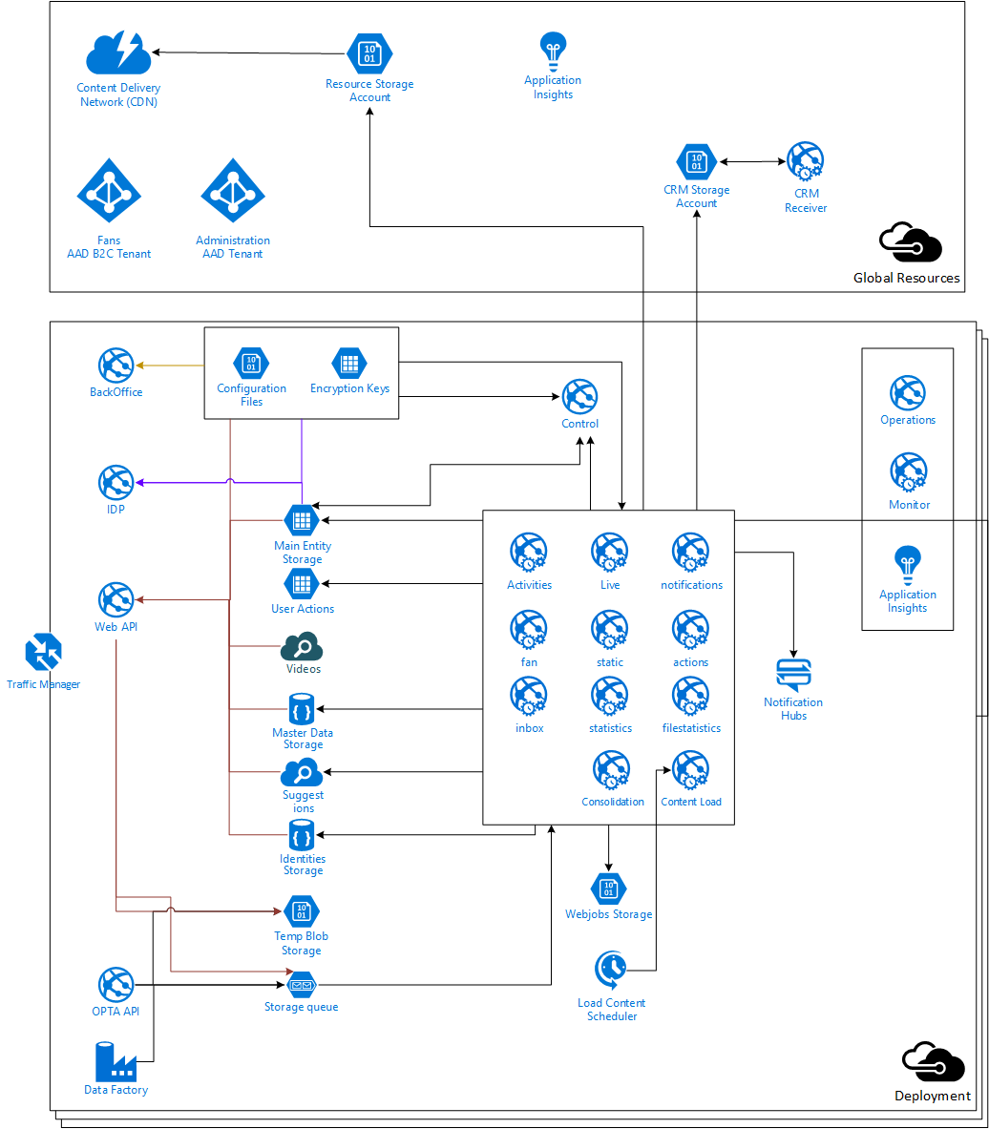

|  |  |
| --- | --- |
| Component | Description |
| BackOffice website | The BackOffice website provides a single page application that provides access to the management functionality of the Web API.  It is hosted in its own Azure Web App because usage will be limited to the customer’s employees and it may not be necessary in all deployments. |
| Web API website | The Web API website hosts the REST service that exposes all Digital Platform functionality.  This area is the main point of interaction in the platform and it will be present on all deployments as the front-end component that will scale the most. |
| Deployment storage | The storage used to support Digital Platform functionality is hosted in different types of storage depending on specific needs. During the deployment, Document DB Databases, Azure Storage accounts, and Azure Search Indexes will be created. |
| Configuration storage | The configuration of the environment will be stored in its own repository as Azure Blobs encrypted during deployment.  All applications will have the public key required to decrypt and validate the configuration files, but only the operations team will have control of the private key to avoid unmanaged changes. |
| Queue/temporal storage | Queue storage is used for two reasons:   * To support the asynchronous. All actions request through the Web API that impact and change values are queued to be processed by the different WebJobs. In this case, the queue allows the solution to scale and avoid creating bottlenecks in the users’ applications. Other scenarios where asynchronous processing is used include syncing information to CRM Online and adding content to the Azure Search indexes. * To replicate and sync data between different deployment. Each deployment will have dedicated queues to send commands that have to be replicated to other deployments.   The usage of Queues in the platform uses a sharding strategy that enables using multiple queues for the same topic, which increases the scalability of the solution. You can expect to see multiple physical queues created per logical Queue. |
| Notification Hub | Notification Hub is used to send notifications to mobile apps. |
| Administration Azure Active Directory | This directory is used to manage all the customer’s users that manage the platform. The Web API trusts this AAD and gives privileges to manage content to users that have valid roles in this tenant. |
| Fans Azure Active Directory B2C | This directory provides the identity of the fans for the platform. It manages federation with social identities and provides its own repository of identities used when fans do not want to register or share their social identities.  The Web API trusts this AAD B2C tenant to use the general services of the platform. |
| WebJob control | This is a website that provides a single point of control for all WebJobs running in the platform. This service takes care of making the WebJobs aware of the sharding used by the queues and implements a heartbeat control that allows monitoring the state of the WebJobs. |
| WebJobs | Azure WebJobs are used to provide offline processing capabilities to the platform. In most cases, the WebJobs are processing messages received through queues and they communicate with the WebJob Control to schedule their work and report their state.  WebJobs are deployed in their own app service hosting to avoid interference with the user facing sites and to scale independently. |
| Application Insights | Visual Studio Application Insights is used across the platform to provide support for two scenarios:   * Telemetry. App Insights is used in all components to monitor and register the state of the solution. This information is used mostly to operate the platform. * Usage of the platform. The REST API and many of the components use App Insights to report the actions and behavior of users. This information provides a better understanding of the fans and the platform. Most of the data generated in this case is used by the Analytics platform to provide insights into the platform to the business decision makers. |
| Operation websites | The operation websites provide simple web interfaces for the operations team to observe and review metrics and information collected in the deployment. |
| CDN | The CDN edges used to provide the content managed with the BackOffice will be created as part of the deployment. |

1. Installation Strategy

The installation of a cloud-based solution has the clear advantage in that it can be easily automated. The project has created different artifacts that will be used to deploy the solution:

* + Deployment scripts. These PowerShell Scripts drive the deployment workflow and provide the logging capabilities to troubleshoot deployments.
* Resource templates. These JSON files define the resources created in the environment and are used as the input for the PowerShell Deployment Scripts.(Basically Configuration files)
* Parameter files, these files contain a list of parameters for the environment being configured and are used to generate the Deployment and Configuration json files.
* Custom provisioning operations. These custom [PowerShell CmdLets](https://technet.microsoft.com/en-us/library/dd772285.aspx)[1] are used to provide additional capabilities required to provision the environment.

**The deployment scripts will drive the process, as described in this document: however the configuration of the environment is up to the team deploying the solution.** To improve the management and usability of the platform the following conventions are suggested for the installation/deployment of the solution:

* Use a single resource group for deployment to simplify the management of every environment and make it simpler to remove failed or obsolete deployments.
* Use a single resource group for global resources to provide a clear understanding of all resources being used by all deployments.(ARM)
* Use the deployment ID in the name of the resource group and resources to make it clear to the deployment they belong to.
* For the initial deployment, start with all deployments even though they may not be used. This best practice will simplify and validate the data replication topology.
* Provide different units of scale for all web components, which will allow you to tune and grow the platform without having unexpected dependencies.

1. Deployment Resources

Use this section to identify the staffing that will be needed to complete the deployment and the sources of the personnel (internal staff, contractors and so on).

To deploy a complete environment for the solution, the following software must be set up:

* **Microsoft Azure subscription**
* **Microsoft .NET framework 4.6 or more**
* **Microsoft Azure PowerShell 2.0.1 (Installer: [link](https://github.com/Azure/azure-powershell/releases/download/v2.0.1-August2016/azure-powershell.2.0.1.msi))**
* **Microsoft Dynamics CRM Online Tenant**
* **Microsoft Dynamics Social Listening Tenant**
* **Microsoft Dynamics Marketing Tenant**
* **Visual Studio Team Services Project (required for the build step; if you will simply be deploying the solution, you won’t need it)**

You will need to have users that have access and permissions to execute the following tasks:

* Co-administrator of the Azure subscription where you will deploy the Digital Platform.
* Global administrator of the Azure Active Directory Tenants if you will be using an existing AAD Tenant.

1. Azure AD tenants and Apps

This section walks you over the steps required to provision and configure the Azure AD tenants and the apps that will be used by the solution.

* 1. Azure AD Admin tenant

This Azure AD (AAD) tenant will be used by the customer’s personnel to manage the platform. The creation of an AAD is at the subscription level, which means your user must be a subscription co-administrator.

Create your own AAD tenant or ask the customer access to their existing AAD tenant. Note down the domain name for the tenant you are creating (xxx.onmicrosoft.com) and the tenant id (from the URL in the classic azure portal)

[Create the following web applications](https://azure.microsoft.com/en-us/documentation/articles/active-directory-integrating-applications/) in the AAD Tenant.

**Note:** Web apps MUST have the implicit flow enabled as described here.

**Note:** For multi-environment configurations, you can create a single web application per each AAD tenant, and then specify as many Reply URLs in the app’s configuration screen as the number of your deployment locations. And for the production environment you may always want to have the Reply URL corresponding to the Traffic Manager URL.

**You also** need to create two roles[2] (***PlatformAdmin*** and ***ContentAdmin***) in both Web Admin and Web API web applications that you’ll be creating. The roles manifest is available in Appendix A: Application Role Definition.

|  |  |  |  |  |
| --- | --- | --- | --- | --- |
| Name | Type | SIGN-ON URL | APP ID URI | Config Notes |
| MDP - Web API | Web App | https://[custId]-[env]-[region]-web-api.azurewebsites.net/ | http://[custId].digitalplatform.ms/web/api | Create a key and copy it. You will use in the configuration file.  Set User Assignment Required to Access App to “YES” |
| MDP - Web Admin | Web App | https://[custId]-[env]-[region]-web-admin.azurewebsites.net | http://[custId].digitalplatform.ms/web/admin | Grant delegated access to the Web API application;  Set User Assignment Required to Access App to “YES” |
| MDP - Web Control | Web App | https://[custId]-[env]-[region]-web-control.azurewebsites.net | http://[custId].digitalplatform.ms/web/control | Create a key and copy it. You will use in the configuration file. |
| MDP - Web Load Content Job | Web App | https://[custId]-[env]-[region]-web-loadcontent.azurewebsites.net | http://[custId].digitalplatform.ms/web/loadcontent | Grant delegated access to the Web Control application.  Create a key and copy it. You will use in the configuration file. |
| MDP - Web Operations | Web App | https://[custId]-[env]-[region]-web-operations.azurewebsites.net | http://[custId].digitalplatform.ms/web/operations | Grant delegated access to Azure Service Management  Create a key and copy it. You will use in the configuration file. |
| PowerShell Scripts | Native Apps | [http://localhost](http://localhost/) |  | Set the redirect URL to http://localhost.  Grant delegated access to the Web API application. |

* 1. Assigning users and groups to application roles

After you upload all the manifests back to AAD, make sure the **User Assignment Required To Access APP** control is enabled, and the users in your Active Directory are assigned accordingly to their authorization level (must be consulted with the customer). These roles must be assigned for **Web API** and **Web Admin** applications.

Then, after a global administrator of the customer’s organization has added their users into the AAD directory, either they themselves or a user accounts administrator in their organization can assign users and groups to Sports applications: navigate to the users tab under the application to which you would like to assign users and groups. Select a user and click on the **Assign** action on the bottom bar. Here you can assign the desired role to the user.

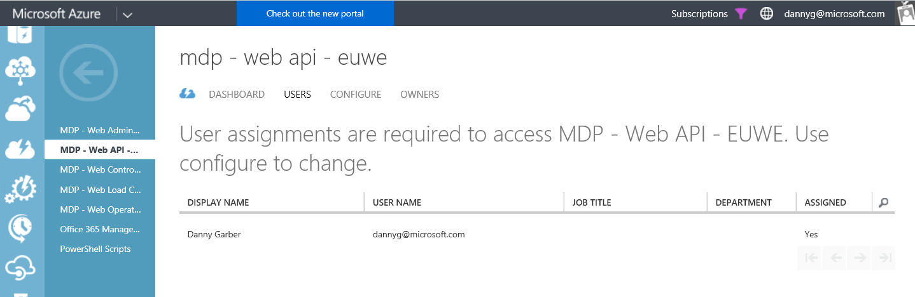

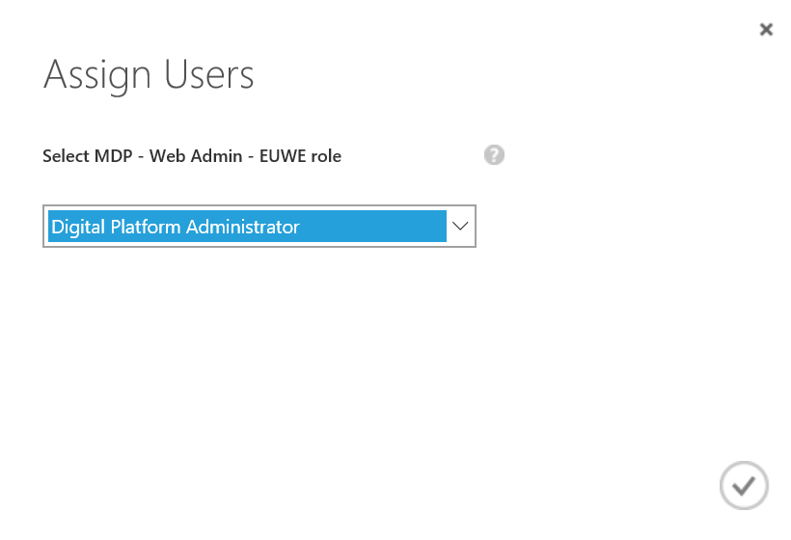

* 1. Azure AD B2C Fans tenant

This Azure AD (AAD) tenant will be used by to provide a single identity to all fans connecting to the platform. The creation of an AAD is at the subscription level, which means your user must be a subscription co-administrator.

1. [Create an AAD B2C Tenant](https://azure.microsoft.com/en-us/documentation/articles/active-directory-b2c-get-started/).(Note down the tenant name (xxx.onmicrosoft.com) and tenant id .
2. [Create the following custom attributes](https://azure.microsoft.com/en-us/documentation/articles/active-directory-b2c-reference-custom-attr/) to the User attributes collection. All names are case sensitive.

To access the B2C settings click on the Manage B2C settings under the b2c Administration in the Configure page of the directory you just created:

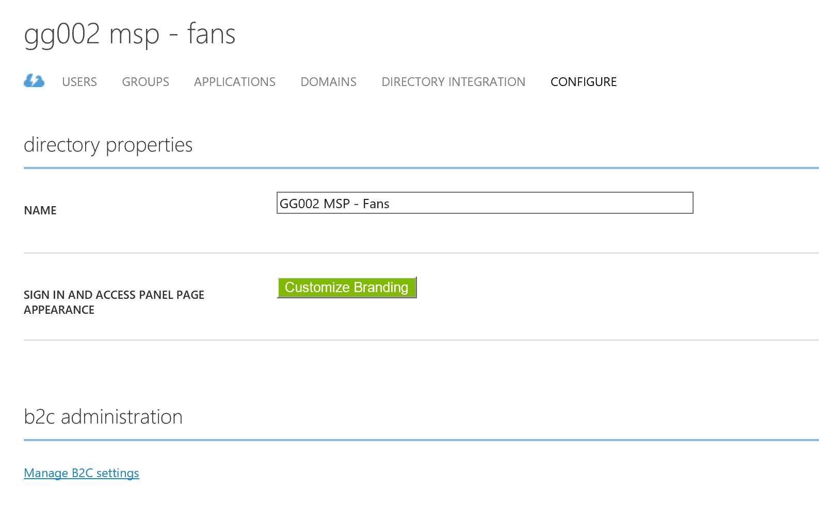

Then, you can add a new custom attribute by accessing the collection of User Attributes as it is shown on the following screenshot:

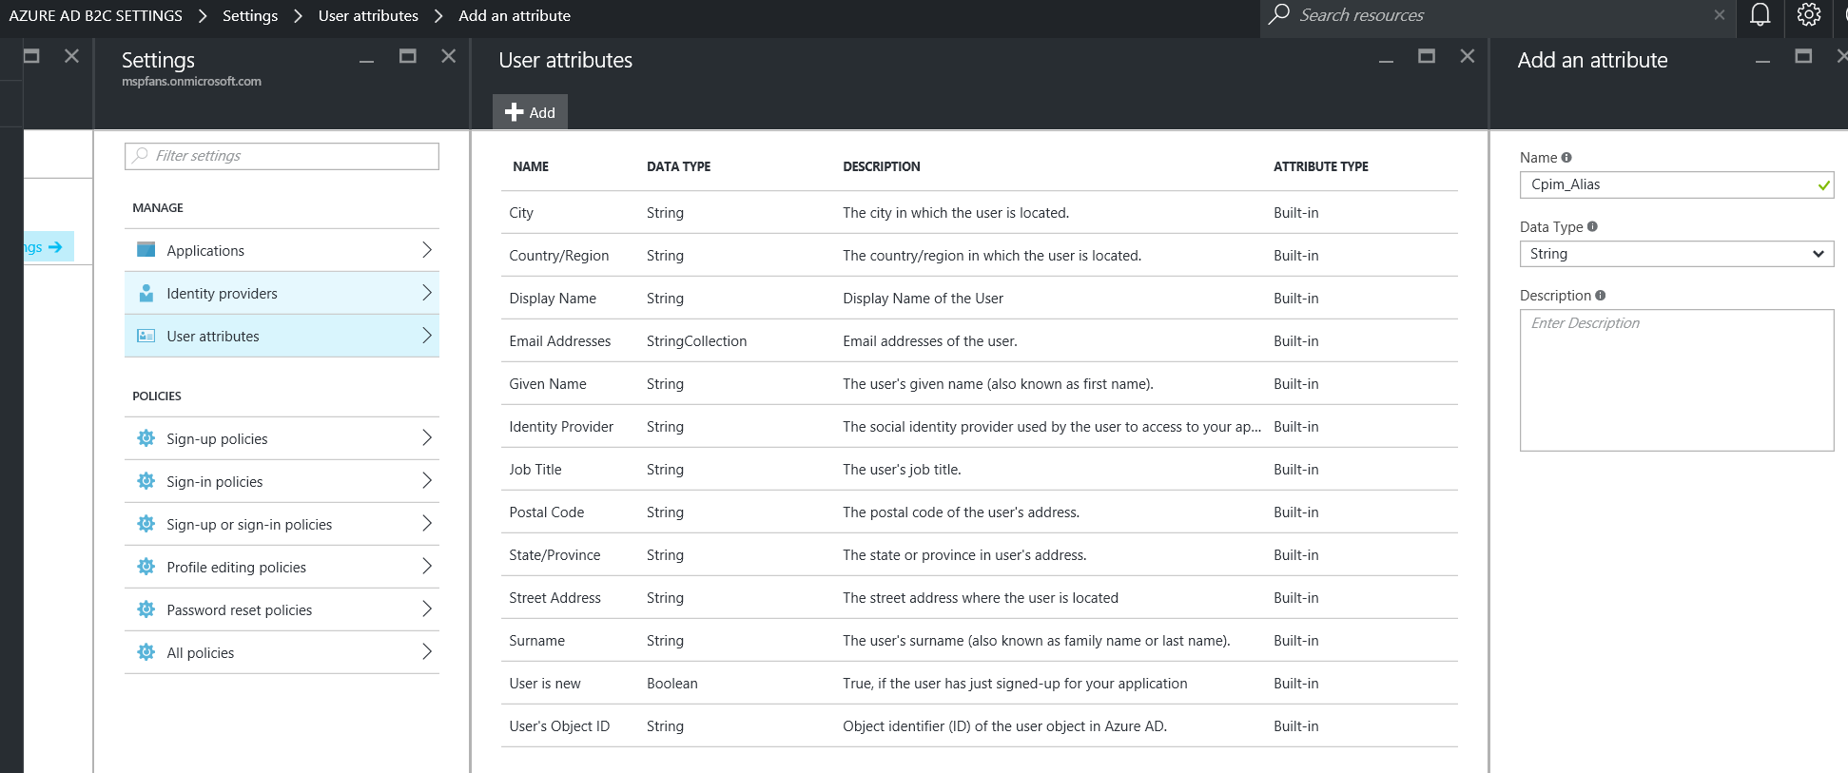

The list of all custom attributes is listed below:

|  |  |
| --- | --- |
| Name | Type |
| Cpim_Alias | String |
| mdpCpim_AvatarName | String |
| Cpim_AvatarThumbnailName | String |
| Cpim_BirthDate | String |
| Cpim_ContactEmail | String |
| Cpim_DisableDate | String |
| Cpim_DocumentNumber | String |
| Cpim_DocumentType | String |
| cpim_Email | String |
| Cpim_FanCardType | String |
| Cpim_FanNumber | String |
| Cpim_Gender | String |
| Cpim_HasAvatar | String |
| Cpim_IsActiveMember | String |
| Cpim_IsActivePaidFan | String |
| Cpim_Language | String |
| Cpim_LastPolicyAcceptDate | String |
| Cpim_LastUpdate | String |
| Cpim_MemberNumber | String |
| Cpim_MemberSeatId | String |
| Cpim_MobileNumber | String |
| Cpim_NoSendDataToThirds | String |
| Cpim_NoSendInfoData | String |
| Cpim_Penya | String |
| Cpim_PictureUrl | String |
| Cpim_PreferenceSport | String |
| Cpim_RegistrationDate | String |
| Cpim_SecondName | String |
| Cpim_SendDataToThirds | String |
| Cpim_SendInfoData | String |
| Cpim_SendStoreInfoData | String |
| Cpim_Source | String |
| Cpim_Title | String |

1. [Create a “SignIn or SignUp” policy](https://azure.microsoft.com/en-us/documentation/articles/active-directory-b2c-reference-policies/), call it B2C_1_SignInSignUp and save the policy name to use them in the configuration file (the apps will use these policies during SignIn and Registration).

For Sign-up policy you should add the following attributes:

* 1. **Identity providers**

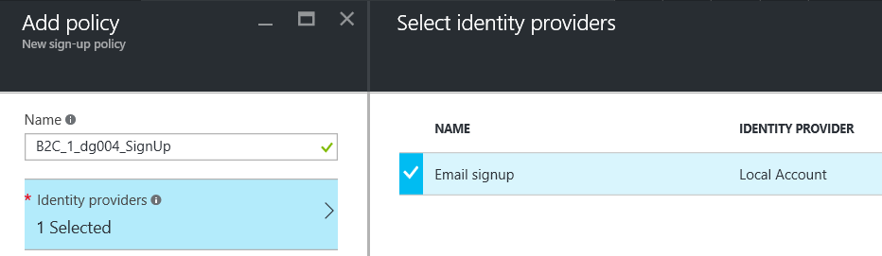

* 1. **Sign-up attributes:**

It is recommended to use at least these fields in the Sign-up policy:

|  |  |  |  |
| --- | --- | --- | --- |
| NAME | LABEL | OPTIONAL | TYPE |
| Cpim_Language | Language | No | DropdownSingleSelect |
| Cpim_LastPolicyAcceptDate |  | No | TextBox |
| Cpim_LastUpdate |  | No | Text Box |
| Cpim_NoSendDataToThirds | Don't send data to 3rds | No | RadioSingleSelect |
| Cpim_NoSendInfoData | Don't send info | No | RadioSingleSelect |
| Cpim_RegistrationDate |  | No | Text Box |
| Cpim_SendStoreInfoData | Send store info | No | RadioSingleSelect |
| Cpim_Source | Source | Yes | TextBox |
| Email Addresses | Email Addresses | No | TextBox |

* 1. **Application claims:**

The minimum selected field requirements are: **Email Addresses** and **User’s Object ID**, but you may consider adding the following claims must be selected:

|  |
| --- |
| NAME |
| Cpim_Language |
| Cpim_NoSendDataToThirds |
| Cpim_NoSendInfoData |
| Cpim_SendStoreInfoData |
| Cpim_Source |
| Cpim_SendInfoData |
| Cpim_SendDataToThirds |
| Country/Region |
| Display Name |
| Email Addresses |
| Given Name |
| Identity Provider |
| Surname |
| User is new |
| User’s Object ID |

* 1. Leave all other settings **default.** Then click **Create**.

**Note:** You can add other attributes if needed, but consider that adding too many fields may result in larger authentication codes and errors during authentication.

1. Create the following applications using the old azure portal:

|  |  |  |  |
| --- | --- | --- | --- |
| NAME | TYPE | Reply URL | CONFIG NOTES |
| MDP - Identity Provider | Web App | https://[custId]-[env]-[region]-web-idp.azurewebsites.net  App ID URI:  http://[custId].digitalplatform.ms/web/idp | Create a key and copy it to be included in the configuration. |
| MDP - Web API | Web App | https://[custId]-[env]-[region]-web-api.azurewebsites.net  App ID URI: http://[custId].digitalplatform.ms/web/api | Grant read/write permission on the directory to the application.  Create a key and copy it to be included in the configuration. |
| MDP - UWP - Phone | Native App | http://localhost |  |
| MDP - UWP - Tablet | Native App | http://localhost |  |
| MDP - Android - Phone | Native App | http://localhost |  |
| MDP - Android - Tablet | Native App | http://localhost |  |
| MDP - iOS - Phone | Native App | http://localhost |  |
| MDP - iOS - Tablet | Native App | http://localhost |  |

* 1. B2C Custom Policies

While B2C primarily allows end customers (fans) to sign-up and sign-in using local email account and by using external identity providers like Facebook, Google using built-in policies; it further extends the experience by invoking REST API’s hosted by the digital platform. These APIs establish Fan identity of the new user in the platform and proceed to records user actions.

B2C provides an active-directory-b2c-custom-policy-starterpack that can be downloaded from GitHub [link](https://github.com/Azure-Samples/active-directory-b2c-custom-policy-starterpack/archive/master.zip). Please follow this [article](https://docs.microsoft.com/en-us/azure/active-directory-b2c/active-directory-b2c-get-started-custom) to build your customer specific customized B2C policies. The startup pack will consist of various policy xml files that will have to be edited to a specific customer requirement. We use TrustFrameworkBase.xml to create base policy for our reference implementation.

Following section describes a reference custom policy implementation with following features:

1. User sign-up using local email
2. User sign-in using registered email
3. Facebook sign-in
4. Google sign-in
   * 1. Local Account Sign-In

Claims provider section has a series of technical profile corresponding to each of the identity providers. Below technical profile “login-NonInteractive” provides local account sign-in experience. Output claims are those that are returned by the identity provider and you may want to keep those that are applicable to your implementation.

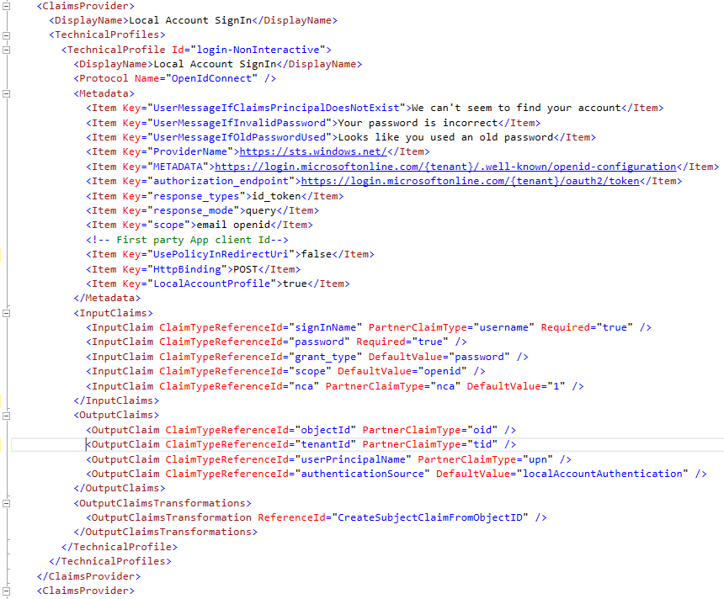

Image 1: Local Account Sign-In policy section

* + 1. Facebook Sign-In

Below technical profile corresponds to that of Facebook identity provider. Client Id corresponds to the App ID that you setup in Facebook and goes as a direct text in the policy. The “client_secret” corresponds to the App Secret provided by the Facebook app. This is provided as a key name “B2C_1A_FacebookSecret” in the custom policy and not direct text. The key itself is created in the B2C tenant with the value extracted from Facebook app.

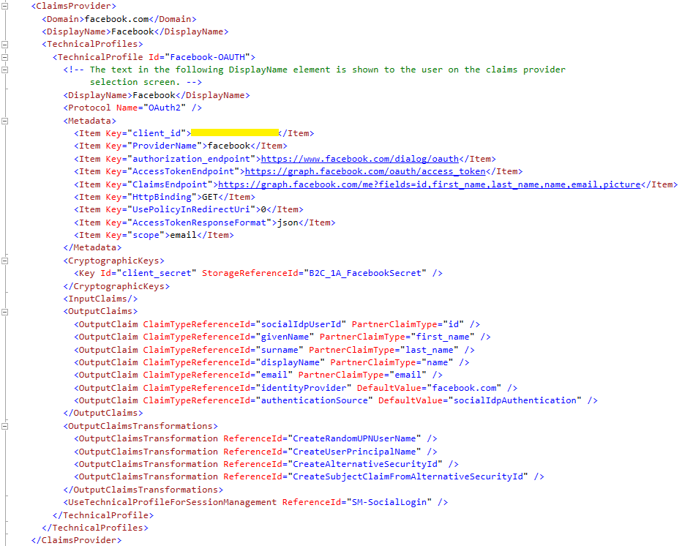

Image 2: Facebook technical profile

The App ID and App Secret can be found on the basic settings page of your Facebook App setup as an Identity provider. Please follow [this](https://docs.microsoft.com/en-us/azure/active-directory-b2c/active-directory-b2c-setup-fb-app) link to setup Facebook as an Identity provider.

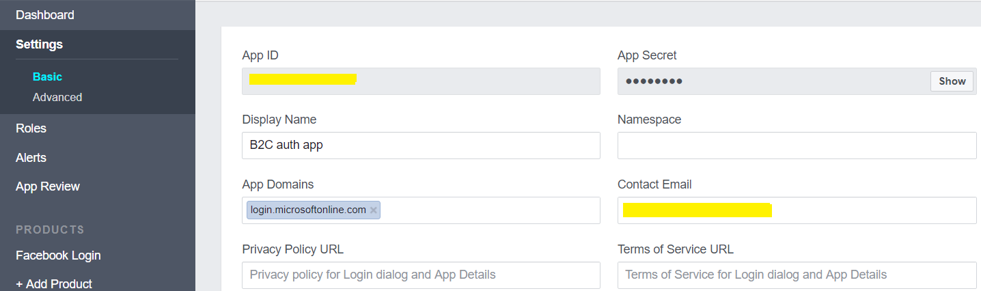

Image 3: Facebook App ID and Secret

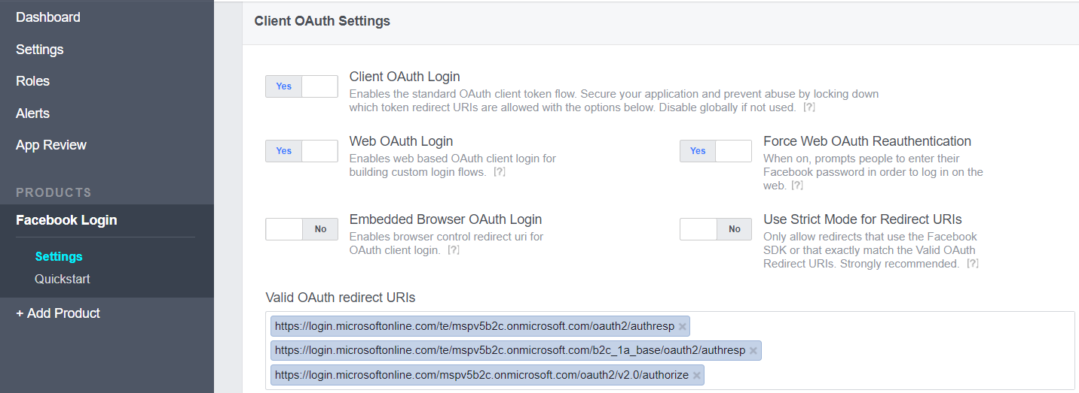

Image 4: Facebook App redirect URIs

* + 1. Google Sign-In

Below technical profile corresponds to that of Google identity provider. Like Facebook, client_id field is extracted from the Web Application you create in Google and is recorded as a clear text in custom policy. Follow [this](https://docs.microsoft.com/en-us/azure/active-directory-b2c/active-directory-b2c-custom-setup-goog-idp) link to setup Google Identity Provider Application. The “client_secret” corresponds to the App Secret provided by the Google app. This is recorded as a placeholder key (named “B2C_1A_GoogleSecret”) in the custom policy’s “StorageReferenceId” and not direct text. The key itself is created in the B2C tenant with the value extracted from Google app.

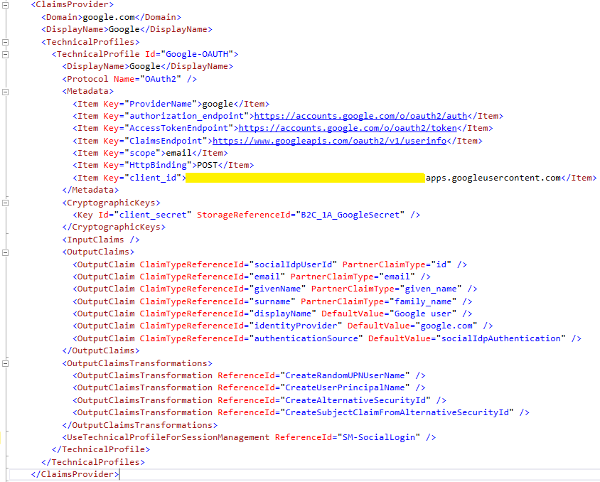

Image 5: Google technical profile

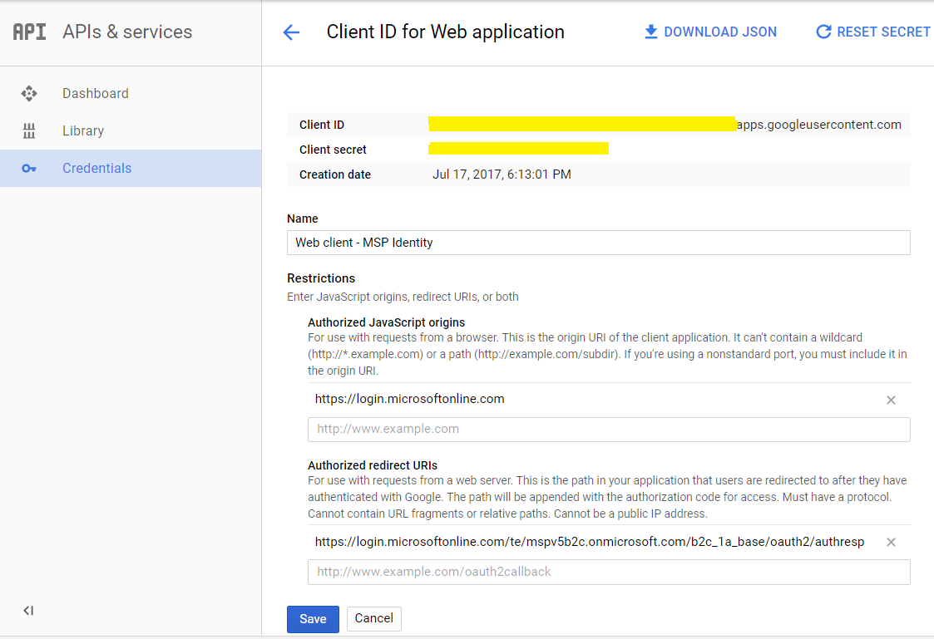

Image 6: Google client ID & secret

* + 1. Invoke RESTful APIs

Custom policies provide an ability to invoke RESTful APIs that extends the out-of-box B2C user experience with the custom platform implementation. In this reference implementation the RESTful APIs are invoked upon signup and essentially records the user as a Fan. It further records the user action (i.e. fan sign-up/sign-in).

Below technical profile in the custom policy corresponds to the first REST API that gets called upon first user sign-up. Note that the InputClaims are passed along as parameters to the first REST call.

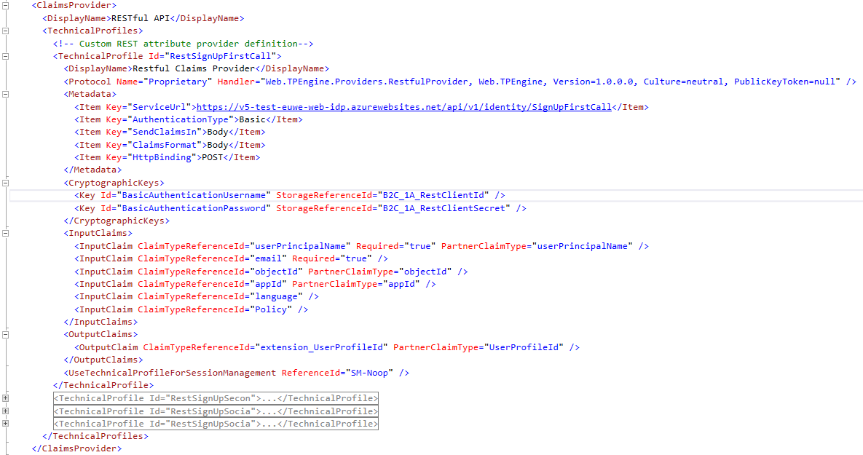

Image 7: Technical Profile for REST Call

Following profile corresponds to the REST API that gets called upon social sign-up i.e. when sign-in happens from one of the external identity providers (Facebook/Google). This call also records the registered user as a Fan in the sports digital platform.

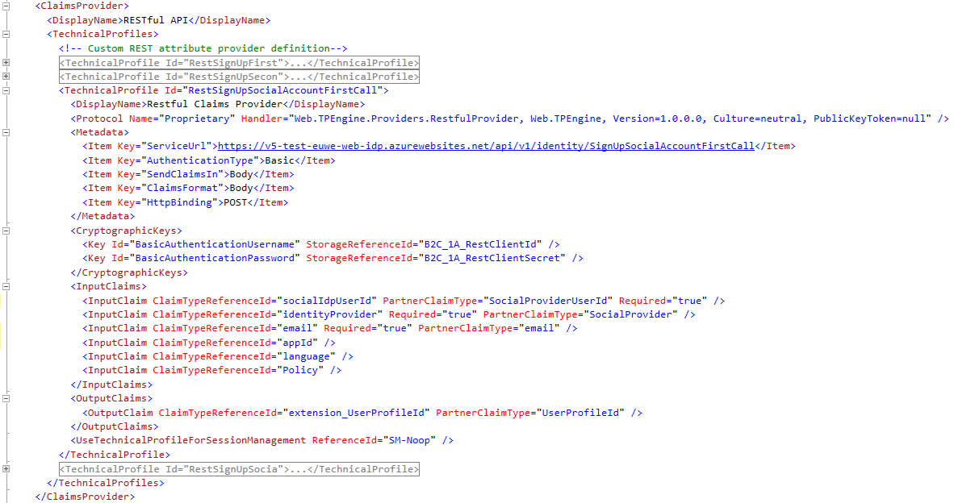

Image 8: Technical profile for Social REST API

Custom policy startup pack will also include default AD related technical profiles that are used for example to write user profile to Azure AD B2C. Some of these technical profiles are named as AAD-Common, AAD-UserWriteUsingAlternativeSecurityId etc (basically those prefixed with AAD).

* + 1. User Journey

Technical profiles described above are combined to provide an end-to-end user experience. The profile “LocalAccountSignUpWithLogonEmail” in below image is responsible for invoking the REST call to add the user as Fan and also create its profile in AD B2C. This is achieved by creating ValidationTechnicalProfiles as below.

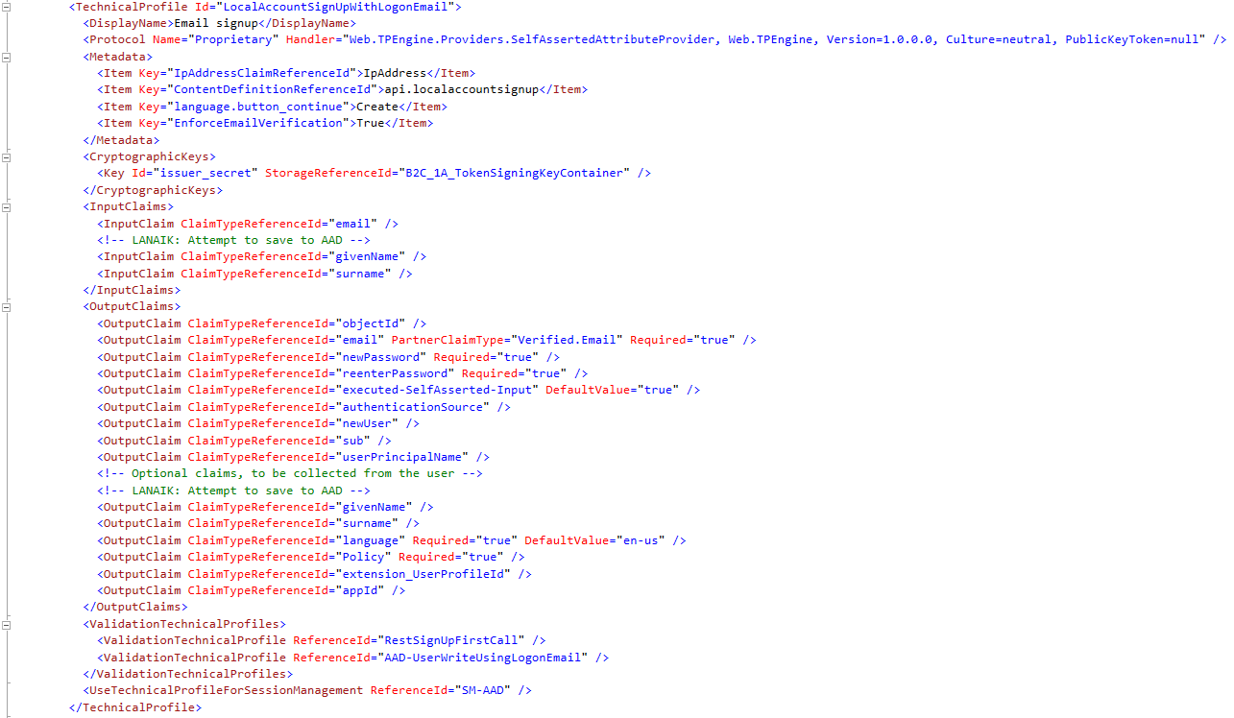

Image 9: LocalAccountSignUpWithLogonEmail technical profile

Similarly, “SelfAsserted-Social” technical profile provides user experience when user sign-in from external identity providers (Facebook/Google) by first establishing Fan identity of the user and later adding user-profile to the AD B2C.

Finally, the User Journey section of the custom policy enlists the various orchestration steps that are to be executed in the entire journey. User Journey use technical profiles to orchestrate the overall sign-up/sign-in journey of the user.

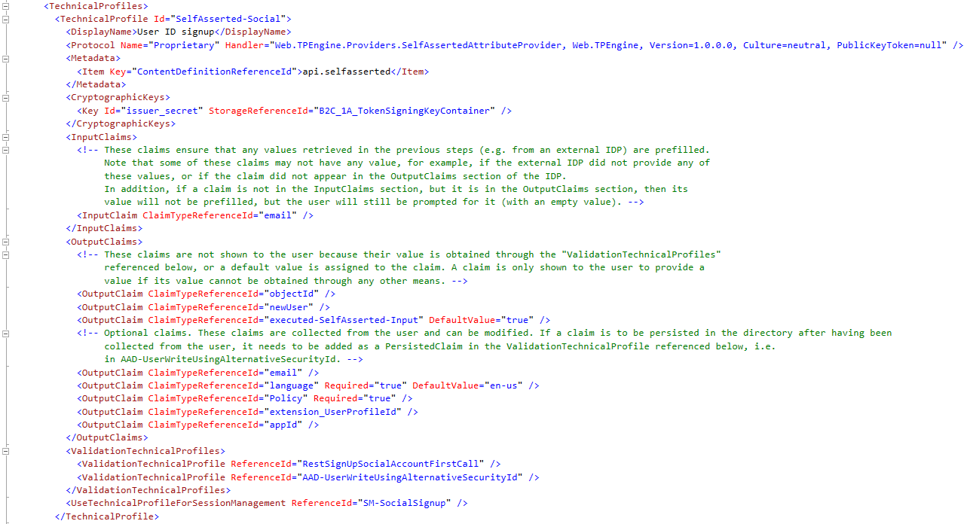

Image 10: SelfAsserted-Social technical profile

* + 1. Uploaded Policies

The policies created using the steps listed above are uploaded in the B2C blade of your Azure AD B2C tenant.

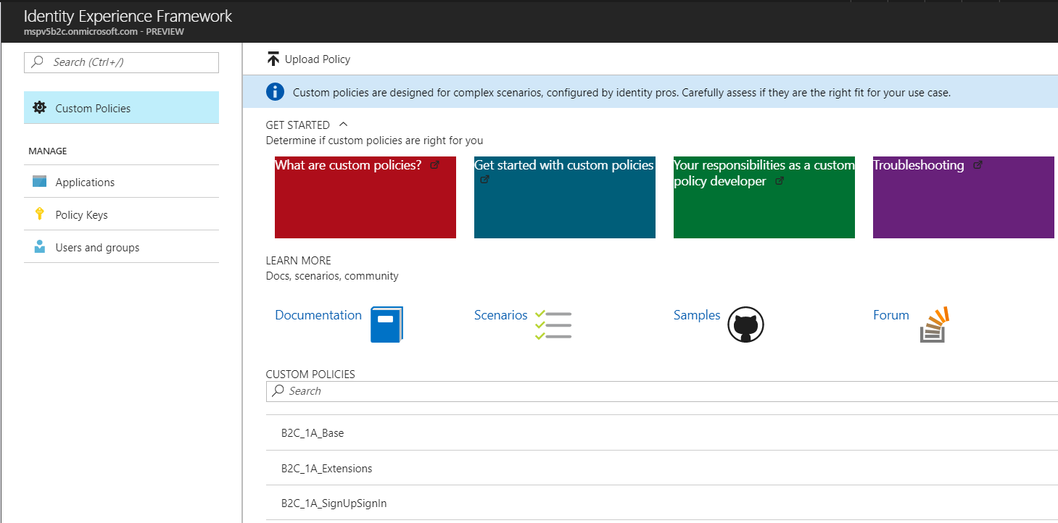

Image 11: Identity Experience Framework B2C blade

The end customer application through which Fans will access the platform will have to be authenticated in the B2C tenant. B2C will use application ID to authenticate the app.

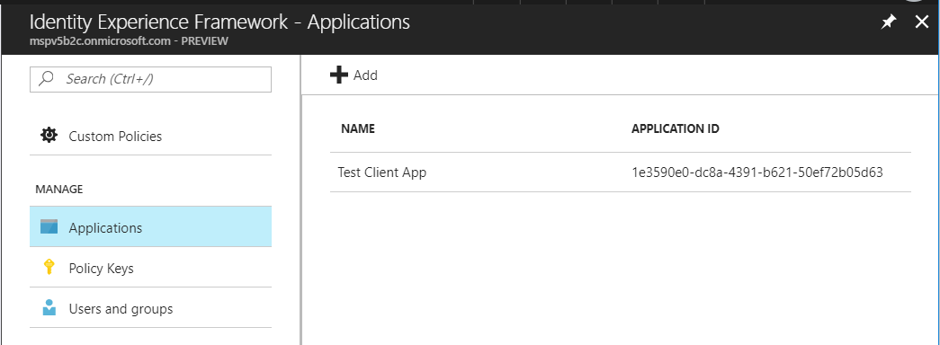

Image 12: Identity Experience Framework- Applications

* + 1. Testing Custom Policies

Azure facilitates testing of custom policies through Identity Experience Framework. Select SignUpSignIn policy from Identity Experience Framework blade of the B2C.

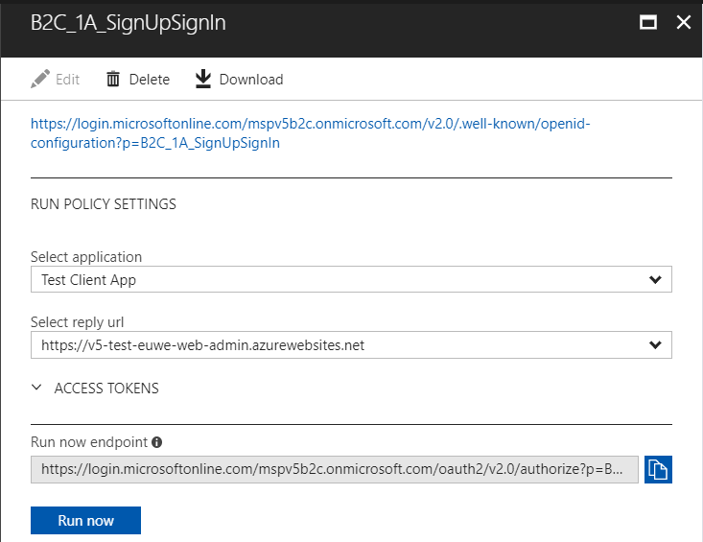

Image 13: Test User Experience- Run now

Select the application that is registered on B2C tenant. Reply URL here is the redirect URL where B2C will return token. Click on Run now to see following user sign-up, sign-in page. Notice all the options available on this page are corresponding to those listed in the User Journey section of the custom policies. Proceed to test all the flows as created in your custom policies.

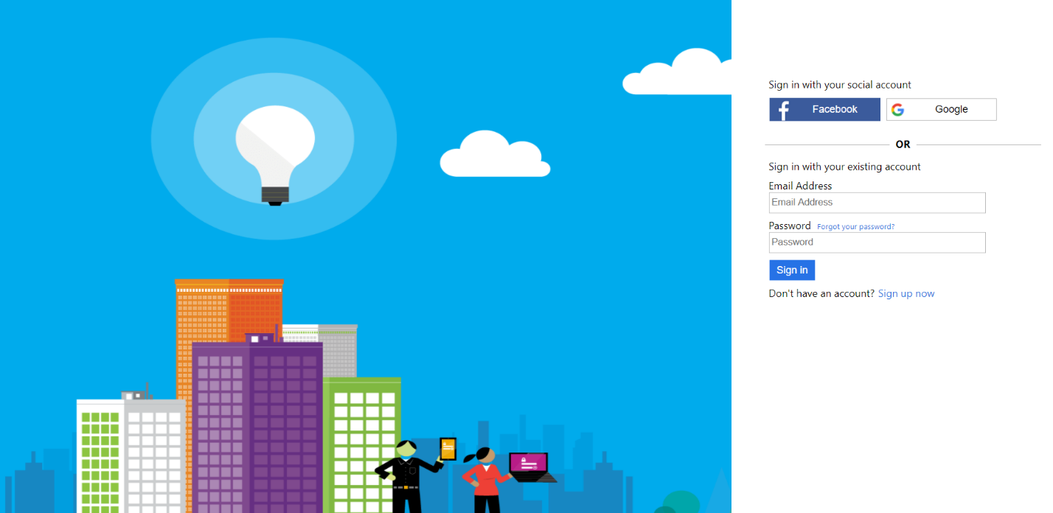

Image 14: Test end-to-end User Experience

1. Digital Platform Build
   1. Preparing

Before trying to compile the solution, make sure you have the following software installed:

* Microsoft Visual Studio 2015 Enterprise with Update 3
* .NET Framework 3.5
* .NET Framework 4.6

**Note:** To check whether you have .NET Framework 3.5 and 4.6 enabled on your machine, go to Start->Programs and Features-> Turn Windows features on or off and verify that both .NET Framework 3.5 (includes .NET 2.0 and 3.0) and .NET Framework 4.6 Advanced Services are installed

* 1. Compilation

This section describes the steps required to build the solution from the command prompt using MSBuild.

1. Open the Developer Command prompt and navigate to the local folder of the solution.
2. Navigate to the DigitalPlatform/Build folder and execute.

MSBuild LocalBuild.proj /p:ConditionDeployOnBuild=true

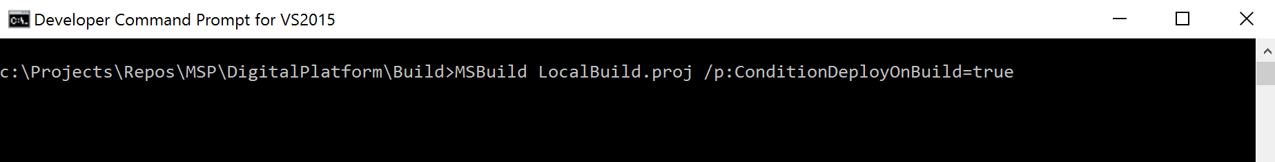

This may take between 10 and 15 minutes the first time between downloading all NuGet packages and actual compilation.

**Note:** Expect warnings during the compilation for several reasons (XML Missing comm ents, await, unused variables, etc.).

* 1. Verification

Once the build completes there will be a new folder *DigitalPlatform\Binaries.* If the build completed successfully, there will be a subfolder called Version with the following structure:

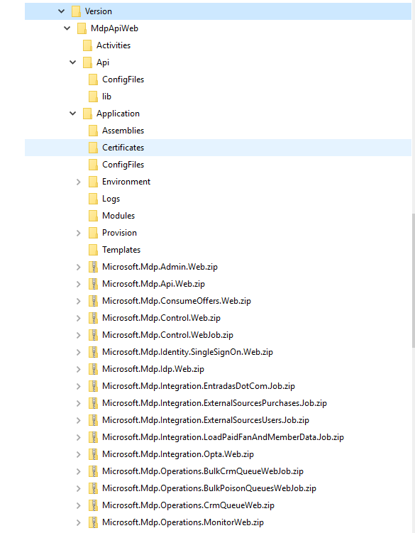

1. Azure Setup Process

The following process will create all Azure resources required to run the Core Digital Platform. This process should be run only during the initial setup of a deployment or during the addition of a new one.

* 1. Preparing

Before running the process make sure you have the following pre-requisites:

* You have compiled the project following the steps provided in the Digital Platform Build section.
* Before running the command, make sure that you have your subscription registered both for Azure Service Management and Azure Resource Management.

Because the script still uses Azure Service Management, your user must be co-administrator of the subscription.

The team is working in a full Azure Resource Management version of the scripts, but it will not be possible until all services have a resource provider.

* Create your own Environment Deployment File. Look at Section 4 Deployment Resources to get an explanation of the different components included in the environment and the file description.

You must know what your environment is going to look like in terms of deployments and services available in each deployment.

A complete environment definition is available at *DigitalPlatform\Deploy\ConfigFiles\AzureEnvironmentDeployment.SPORTS.json.*

You can commit your definition to the repo to keep track of it.

* Create your own encryption certificates using the makecert utility (Windows SDK). They will be used to encrypt the configuration files of the environment.

You can find the commands to create the certificates in the file *Digital Platform\Deploy\Certificates\createcert.txt*

* Note down the Certificate name given in the CN attribute. This should be provided in the Azureenvironmentparameters file.
* After you run the commands, export the PFX and CER files for the certificate.[3]
  + - Some screen shots using Microsoft management console for Exporting certificates are given below

MMC – Certificate tree node

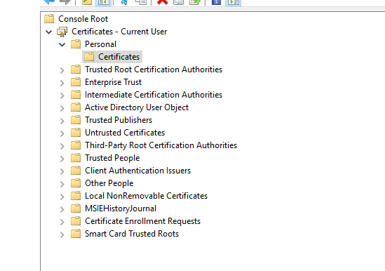

Export Certificate screen

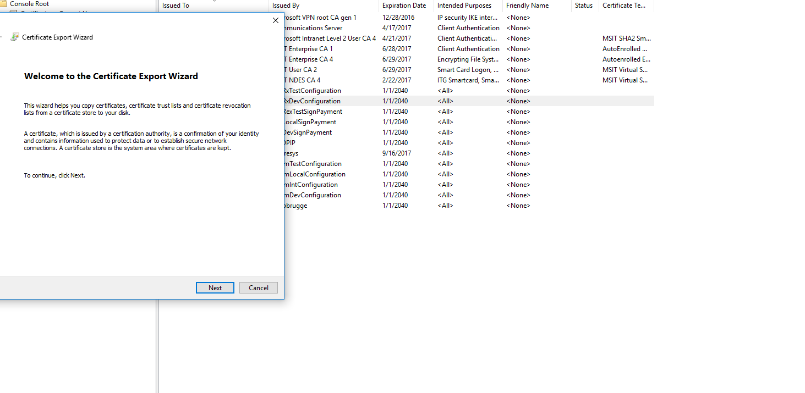

* Copy the pfx and certificate files into the Binaries\Version\MdpAPiWeb\Application\Certificates folder
* You can commit your certificates to the repo without the password used to export the private key.
  1. Resources Provisioning

The provisioning of all resources in Azure requires different steps that will be described in this section. The deployment will be complete and functional only when all steps in this section have been successfully completed.

* + 1. Scripted Resource Provisioning

The Core Digital Platform provides scripts to create most of the resources required to by the solution. These scripts are based on Azure PowerShell and will provide a log to register all actions executed during the provisioning.

1. Update the following tokens in your parameters file (1 Region or 2 Region depending on the target environment):

[custId]

[env]

[globalRegionLocation]

[region1DeploymentId]

[region1Id]

[region1Location]

[region2DeploymentId]

[region2Id]

[region2Location]

1. Execute **MDPShell.cmd** located under Binaries\Version\MdpApiWeb\Application\. This will open and initialize a PowerShell window that you can use to run the deployment scripts. Also open a new MDPShell for every deployment since MDPShell caches modules from previous deployments and you may encounter unexpected errors down in the deployment process if you do not open a new shell.
2. Modify the Application insights location in both the template files AzureEnvironmentDeployment.2Regions.Template.json and AzureEnvironmentDeployment.1Region.Template.json from Central US to a location where AppInsights is available . See article - [here](https://azure.microsoft.com/en-in/updates/application-insights-general-availability-in-additional-regions-and-resource-location-update-east-us-south-central-us-west-europe-and-north-europe/).
3. Once you update the parameters file run the following command to generate the deployment file updated with your parameters (use the values you defined for **[custId]** and **[env]** token in the parameters of the command):

Merge-MdpTemplateWithParameters -TemplateConfigurationFile .\ConfigFiles\AzureEnvironmentDeployment.2Regions.Template.json -ParametersFile .\ConfigFiles\AzureEnvironmentParameters.**[custId]**.**[env]**.json -OutputFile .\ConfigFiles\AzureEnvironmentDeployment.**[custId]**.**[env]**.json

1. Run the following commands (3 separate commands), replacing the name of your ***subscription*** and the name of your ***config*** file that was created in the previous command (AzureenvironmentDeployment.[custid].[env].json):

1.Register-MDPDeploymentEnvironment

2. Connect-MDPAzureSubscription -SubscriptionName "***[Subscription Name]***"

3. New-MDPAzureDigitalPlatform -Subscription "***[Subscription Name]***" -ConfigFile .\ConfigFiles\AzureEnvironmentDeployment.***CONFIG***.json

* The deployment scripts will have a few interactions:
  + The PowerShell script will ask you to log in to Azure to get access to your subscription.
  + The same command will also ask you **twice or more** for the password to access the PFX certificate private key for each resource group where the certificate is uploaded.

**Note:** In case of failure or disconnection the scripts can be run multiple times without the risk of overwriting already created resources.

Once the scripts complete the following resources will be created:

* Azure Resource Groups
* Azure Storage accounts
* Azure Notification Hubs
* Azure Document DB accounts
* Azure Search accounts
* Azure App Hosting plans
* Azure Web Apps
* Azure Applications Insights
* Traffic Manager endpoints
  + 1. Manual Resource Provisioning

After you have completed the scripted provisioning of the environment, there are a couple of manual steps that are required to provision some resources:

* + - 1. Azure Notification Hub

Configure an Azure Notification Hub. That will be used to send push notifications to different Native Apps. You can use the following guide to [Configure the Hub](https://azure.microsoft.com/en-us/documentation/articles/notification-hubs-windows-store-dotnet-get-started/#configure-your-notification-hub).[4]

* You will need at least one hub for all your applications.
* If you want to keep track of spending per application, you should create a hub per application that will be developed.
  + - 1. Configuring SSL Certificates for Azure Traffic Manager

In order for the Azure Traffic Manager to use the HTTPS endpoints, it must be properly configured to accept SSL DNS resolution with the proper certificates installed on the Traffic Manager domain. See this article for more info: <http://www.hanselman.com/blog/CloudPowerHowToScaleAzureWebsitesGloballyWithTrafficManager.aspx>

1. Environment Configuration Files

After creating the resources, you must create the environment configuration file that will be used by all deployment tools included with the Core Digital Platform. You can find examples of the configuration files in the source code under Deploy\ConfigFiles\AzureEnvironmentConfiguration.*.Dev.json.

**Note:** Because keys and access information are stored in the file, you can choose not to store this file in the shared repo and should be pushed to the individual project repo.

After creating all resources, you must get all the keys and connections to include them in the configuration file.

The following is a brief summary of all sections included in the configuration file with some guidance on where to get the values required for its configuration.

* 1. Resources Configuration

Provides keys and connection string for resources that will be referenced in the other configuration elements.

* **Storage accounts.** For every storage account in the Environment Deployment file get the connection string and account name.
  + - If the environment is sensitive, put *TOBEDEFINED* in the connection string so the script gathers the connection information during deployment using the credentials of the user executing the script.
    - Internally, all accounts are referenced by the Name attribute so try to keep those constant between environments to correlate the accounts.
    - If your environment is using the same storage account for multiple purposes, it is recommended that you keep multiple account references to understand the different uses of the account.
    - The suggested storage account references are:
      1. **cdnsa**: Pointing to the storage account used by the CDN. There is only one for all deployments.
      2. **crmsa**: Pointing to the storage account used to keep information used in the synchronization with CRM. Since there is only one CRM tenant there is only one account for all deployments.
      3. For every deployment you MUST create the following references with the deployment id as a prefix. For instance, if the deploymentid is **eu**.

defaultsa -> **eu-**defaultsa

configurationsa -> **eu-**configurationsa

useractionssa -> **eu-**useractionssa

queuessa -> **eu-**queuessa

blobssa -> **eu-**blobssa

Jobssa -> **eu-**Jobssa

* To help with the environment configuration settings, there is a command line for how to get all the storage keys based on the AzureEnvironmentDeployment settings:

***.\Get-MDPAzureEnvironmentSettings*** *-Subscription "****Subscription Name****" -ConfigFile .\ConfigFiles\AzureEnvironmentDeployment.[****CustId****].[****Env****].json*

* **Document DB references**
  + - Make sure to include the right key, administrative, and database name.
    - Consider that MDP only stores the identities in DocDb
    - Just like with the storage account sensitive keys can be marked as *TOBEDEFINED*
* **Azure Search references**
  + - You will have to create a Query Key to be included in the configuration file.
    - For MDP only one search instance is required to keep data of users and groups. However other scripts WILL FAIL if you don't add the *video platform* reference.
    - Just like with the storage account sensitive keys can be marked as *TOBEDEFINED*
  1. Common Configuration

This section has configuration parameters that will be applied to all deployments. If you have a single deployment environment there is not much difference between using this section and the deployment configuration section.

* **InstrumentationLevel**. Defines the level of instrumentation messages to be issued by all the environment.
  + **Configuration**. There is a single notification Hub for the environment so all it is needed is the connection string.
* **WebApiDeploymentBaseAddress**. In case of a multi-deployment environment this should be the Traffic Manager endpoint. Otherwise just the base URL of the Web API site, ex. https://dg004-dev-euwe-web-api.azurewebsites.net
* **OptaDeploymentBaseAddress.** Just like Web API but for the service that OPTA calls.

If your environment has to test this integration, you must contact OPTA and ask them to register the URL, ex: https://dg004-dev-euwe-web-opta.azurewebsites.net

* **PowershellClientId**. This is the ID used by different deployment scripts that call the WebAPI. You have to use the client ID of the PowerShell Scripts application created in the admin tenant.
* **DefaultLanguage**. Self-explanatory
* **WaadConfiguration**. Configuration used by the Batch job and the Web Api to read data and write updates to Azure AD B2C users.
  + - **GraphApiResourceUrl**. The url to Azure Active Directory Graph API service (<https://graph.windows.net>).
    - **GraphApiVerstion**. Current api version
    - **TenantName**. The AAD B2C tenant name, ex. mspfans.onmicrosoft.com
    - **WaadAuthString**. AAD Login URL: https://login.windows.net/{0}
    - **WebApiClientId**. The Client ID of the **MSP WAAD Graph Access App** in the AAD B2B directory (Note: must be retrieved from the old Azure portal)
    - **WebApiClientSecret**. The Client Key of the **MSP WAAD Graph Access App** in the AAD B2B directory (Note: must be retrieved from the old Azure portal)
    - **IdpClientId**. Application ID of the **MDP - Identity Provider** application in the AAD B2C directory (Note: must be retrieved from the new Ibiza Azure portal)
    - **AdminsTenant**. The tenant of the AAD admin directory, ex. mspadmin.onmicrosoft.com
    - **WebApiAdminClientId**. Client ID for the MDP - Web API App created in Azure B2B.
    - **WebApiAdminClientSecret**. Secret created for MDP - Web API App created in Azure B2B.
* **Waadsocialconfiguration**:
  + - **TenantId**: "88c3f7d2-4995-4691-89e7-e8d792a61321",
    - **ClientId**: "88c3f7d2-4995-4691-89e7-e8d792a61321",
    - **ServiceUserId**: "TOBEDEFINED",
    - **ServiceUserPassword**: "TOBEDEFINED",
    - **ProvisioningUrl**: "TOBEDEFINED",
    - **GraphApiResourceUrl**: "TOBEDEFINED",
    - **AuthorityUrl**: "TOBEDEFINED",
    - **FacebookProviderName**: "TOBEDEFINED",
    - "GoogleProviderName": "TOBEDEFINED"
* **OperationsConfiguration**. This is the configuration used by the jobs that monitor the website.
  + - The **TenantId** is the id of the Admin AD you created. (copied from the URL address line of the AAD directory tenant, ex. 
    - The **Subscription ID** is the Azure Subscription ID where you are hosting the solution.
    - The **ClientId** and **ClientSecret** come from the **MDP - Web Operations** app your created in Azure Admin while configuring apps.

Make sure that the application has access to Azure Service Management in Azure AD.

* **CDNConfiguration**. Point to the cdnsa storage account reference and include the CDN endpoint URL.
* **SubscriptionTokenConfiguration**. TODO
* **AkamaiTokenConfiguration** : TODO
* **DRMConfiguration** : TODO
* **OfficialAppsIdClientGroup**. This is the ID of the applications in the BackOffice. During initial deployment use any value and then adjust to the right one.
* **TwitterConfiguration**. You will have to register as a developer in the social network site to get this info.
* **FacebookConfiguration**. You will have to register as a developer in the social network site to get this info.
* **GoogleConfiguration**. You will have to register as a developer in the social network site to get this info.
* **QRCodeDefaultConfiguration**. TODO
* **SMTPClientConfiguration** : TODO
* **PicturesConfiguration**. For every type of pictures (blobs) to be stored you can configure the image processing to be applied. Most properties are self-explanatory

For an example of the suggested configuration check at DigitalPlatform\Deploy\ConfigFiles\AzureEnvironmentConfiguration.SPORTS.json

* **BlobStorageConfiguration**. Defines what containers to create and their characteristics.

For an example of suggested configuration look at *DigitalPlatform\Deploy\ConfigFiles\AzureEnvironmentConfiguration.Dev.json*

* **CacheConfiguration**. Amount of time in minutes to keep objects in cache.
* **SingleSignOnWebConfiguration**. TODO
* **BackOfficeConfiguration**. Login configuration for the Admin website. These settings are based on the **MDP - Web Admin App** that was configured previously in the admin AAD.
  + - **ClientId**. Client ID for the MDP - Web Admin App.
    - **AADInstance**. AAD Login URL: https://login.windows.net/
    - **PostLogoutRedirectUri**. The URL of the Web Admin site that was created during deployment, ex. https://dg004-dev-euwe-web-admin.azurewebsites.net
    - **WebApiUrl**. The URL for the Web API site created during deployment, including the api and the latest API version suffix, ex.

https://dg004-dev-euwe-web-api.azurewebsites.net/api/v1/

* + - **Resource**. The App ID URI of the MDP - Web API App in the Admin Azure AD, ex. <http://dg004.digitalplatform.ms/web/api>
* **ConsumeOffersConfiguration**. TODO
* **IdpConfiguration**. Defines how the IDP website will communicate with Azure B2C. Most of the parameters here come from the **MDP - Identity Provider** app created in the B2C directory.
  + - **ClientId**. The client ID of the MDP - Identity Provider app
    - **ClientSecret**. The client secret for the MDP - Identity Provider app
    - **RedirectUri**. The traffic manager URL of the IDP app.
    - **WebApiUrl**. The traffic manager URL of the Web API.
    - **Resource**. The App ID URI of the MDP - Web API App in the Admin Azure AD.
    - **SignUpPolicyId**. The sign up policy ID created for the Fan B2C.
    - **SignInPolicyId**. The sign in policy ID created for the Fan B2C.
    - **IdpAADInstancesConfiguration**.
      1. **PolicyName**. The B2C signing policy name
      2. **AADInstance**. The Microsoft Online Login URL: https://login.microsoftonline.com/
* **PurchaseWebConfiguration**. TODO
* **ConexflowGatewayConfiguration**. TODO
* **MaxMindConfiguration**. TODO
* **SFTPConfiguration**. TODO
* **ApiConfiguration**. Information about authentication and authorization in the API layer.
  + - Replace the name of the **FansTenant** and **AdminsTenant** Active Directories that you will be using in your deployment.
    - **Audiences**. Add the audiences:
      1. The **Web API Uri** for the MSP Web API App as defined in the Admin Tenant, ex. <https://dg004-dev-euwe-web-api.azurewebsites.net/>
      2. The **App Id** for the MSP Web API App as defined in the Admin Tenant, ex. <http://dg004.digitalplatform.ms/web/api>
      3. The **Application Id** for the MSP Web API App as defined in the B2C Tenant, ex. 6d027ed7-4a93-4317-803a-2764ec02afb1, or see the screenshot example below:

Machine generated alternative text:
* Name O 
Digital Platform - Web API 
A lication Client ID 
f261 

* + **Issuer.** Set the issuer array to the [https://sts.windows.net/***tenantid***](https://sts.windows.net/tenantid) replacing tenantId with the tenant ID of the Fan’s tenant active directory (copied from the URL address line, like shown earlier in this document).

**Note**: You DO NOT need to set the Issuer for B2C. This is configured based on the sign-in policy.

* **ProcessConfiguration**. Configuration values for WebJobs.
* **CommonManagementDeployConfiguration**.
  + **Audiences**. Set this value to the App UDI URI of the MDP - Web control App created in the admin AAD.
  + **AdminsTenant**. Set this value to your admin tenant name (i.e.: contoso.onmicrosoft.com)
* **CommonJobsDeployConfiguration**. Standard configuration for all WebJobs.
  + **Authority**. Update this URL to point to your admin tenant.
  + **JobClientId**. Client ID for the **MDP - Web Control App** created in the admin AAD.
  + **JobClientSecret**. The Key for the **MDP - Web Control App** created in the admin AAD.
  + **ControlResourceId**. The App ID for the **MDP - Web Control App** created in the admin AAD.
* **QueuesConfiguration**. Defines what queues to create and their characteristics.

For an example of suggested configuration look at *DigitalPlatform\Deploy\ConfigFiles*

* **LoadContentsConfiguration**. Sources of content to be crawled. If the XML matches the definition is a single point to provide content to the platform.
* **LoadMatchFeedsConfiguration**. TODO
* **LoadPaidFanConfiguration** : TODO
* **SyncMembersConfiguration**
* **ExternalSourcesConfiguration**. TODO
* **IntegrationConfiguration**. TODO
* **RMServicesConfiguration**. TODO
* **EntradasDotComConfiguration**. TODO
* **XpRankingCalculationConfiguration**. TODO
* **RankingScoreConfiguration**. TODO
* **CleanUpOffersProcessConfiguration** TODO
* **CleanUpFavoriteActionsProcessConfiguration** TODO
* **SyncFavoriteActionsProcessConfiguration** TODO
* **Recurringpurchasesprocessconfiguration** TODO
* **CRMConfiguration**. Configuration for the integration process run against CRM.
* **PurchaseValidationConfiguration**. Configuration for the apps to validate purchases.
* **VideoPlatformConfiguration**. See the Video Platform Deployment Guide.
* **AzureSearchCommonConfiguration**. Configuration used by indexers. Defines where the indexes will be created and where to get the data from.
* **ContentConfiguration**. TODO
* **SeasonConfiguration**. TODO
* **SqlServerConnectionConfiguration**. TODO
* **AVETServicesConfiguration** TODO
  1. Deployment configuration.

In this section specific values can be provided for every deployment based on the ID.

* **DeploymentId**. A unique identifier used to prefix all the components in the deployment, it is normally a two letter abbreviation for the region.
* **ReplicationDeployments**. Where to replicate data ingested in the deployment.
* **ConfigurationAccountReference**. Storage account where the encrypted configuration files will be stored.
* **CoreDeployConfiguration**. Storage and Document DB accounts where the master data will be stored.
* **BlobStorageAccountReference**. Storage account where blobs (pictures and similar) will be stored.
* **NotificationConfiguration**. TODO
* **JobsDeployConfiguration**. Storage account to be used by the WebJobs.
* **CacheDeployConfiguration**. TODO
* **EventHubReferences**. TODO
* **VideoEventHubReferences**. TODO
* **WebSitesReference**. Used to associate web sites with App Insight instances.
* **WebJobsReference**. Configuration of WebJobs.
  + Maps the AppInsight instance.
  + Maps the to be watched by the WebJob.
* **StorageAccountEntityConfiguration**. Storage account where user actions will be stored.
* **DocDBCollectionConfiguration**. Indicates what collections should be created.
* **ContainerConfiguration**. TODO
* **AzureSearchDeployConfiguration**. Indicates what search service the deployment will use.

1. Master Data Provisioning

After you deploy all resources in Azure, you must configure and provision all data required for the MDP to work.

**Note:** Before running the steps described in this section, you must have completed completely the steps in Section 7.2 Resources Provisioning.

The master data is information about languages, countries, and other reference information that is required to setup the Digital Platform. Most of the information provisioned in this stage will be stored in the Document DB Account.

1. Execute MDPShell.cmd located under Binaries\Version\MdpApiWeb\Application\.
2. If you have parameters masked as *TOBEDEFINED* in your Environment Configuration file, make sure that you have your subscription registered both for Azure Service Management and Azure Resource Management before going to the next step.
3. Make sure that there is no Environment configuration tmp file in the Config file folder. If it is there due to a previous run, delete the file before running the following commands.
4. Run the following commands replacing the name of your subscription and the name of your config file:

.\**DeployArtifacts.ps1** -ConfigurationFilePath .\ConfigFiles\AzureEnvironmentConfiguration.***[Env]***.json -Subscripticon "***Subscription Name***"

.\**ProvisionMasterData.ps1** -ConfigurationFilePath .\ConfigFiles\AzureEnvironmentConfiguration.***[Env]***.json

.\**ProvisionInitialData.ps1** -ConfigurationFilePath.\ConfigFiles\AzureEnvironmentConfiguration.***[Env]***.json -environmentfolder ***[Env]***

If you haven't setup a games history folder for your environment expect an error in the last script. However, the environment will be functional.

This script can be run multiple times in case of disconnection or failure without any impact on previously provisioned data.

1. Release Deployment

After you have setup the environment and provisioned the initial data, you can deploy the binaries of the application to your environment. This procedure should be implemented as part of the Application Lifecycle Management Strategy of the project.

**Note:** The release process must always be run after running a local build to make sure the latest version of the package is in the right location.

1. Execute MDPShell.cmd located under Binaries\Version\MdpApiWeb\Application\.

If you have parameters masked as TOBEDEFINED in your Environment Configuration file, make sure that you have your subscription registered both for Azure Service Management and Azure Resource Management before going to the next step.

Because the script still uses Azure Service Management, your user must be an administrator of the subscription.

1. Update the remaining tokens in your parameter file with the keys for the resources and AAD settings that you created in the previous steps and regenerate the configuration file by running:

Merge-MdpTemplateWithParameters -TemplateConfigurationFile .\ConfigFiles\AzureEnvironmentConfiguration.2Regions.Template.json -ParametersFile .\~~Deploy~~\ConfigFiles\AzureEnvironmentParameters.[custId].[env].json -OutputFile .\ConfigFiles\AzureEnvironmentConfiguration.[custId].[env].json

1. Run the following commands replacing the name of your subscription, the name of your config file, and your certificate public key file:

Register-MDPDeploymentEnvironment

Connect-MDPAzureSubscription -SubscriptionName "**Subscription Name**"

**.\ParallelDeploy.ps1** -ConfigurationFilePath .\ConfigFiles\AzureEnvironmentConfiguration.***[Env]***.json -Subscription "***Subscription Name***" -CertToEncryptFilePath .\Certificates\***[Certificate File Name]***.cer

Additionally, you can specify the following parameters

* + **OnlyUpdateConfiguration**. Set it to *$true* to avoid redeploying the apps and only update the configuration files.
  + **SlotName**. By default, all applications are deployed to the staging slot. You can specify a different slot with this parameter. If this is your first run, you may want to run it with slot **Production** to have a functional site.
  + **CheckPublishVersion**. Set it to *$true* to check the version being published.

1. (Skip this step if you used the SlotName "Production" parameter in the previous step)

In the standard cycle, you will deploy to Staging and after completing tests you will enable your application in production by doing a swap. To do so, execute the following commands replacing the name of your subscription, the name of your config, file and your certificate public key file.

.\ParallelSwap.ps1 -ConfigurationFilePath .\ConfigFiles\AzureEnvironmentConfiguration.***[Env]***.json -Subscription "***Subscription Name***"

1. Data Provisioning
   1. Application Data

Finally, the applications will need some basic information about their registration. To provision that information, follow the next steps.

1. Execute MDPShell.cmd located under Binaries\Version\MdpApiWeb\Application\.
2. Open the **EnvironmentData.json** file located in the Application folder and add your environment specifying the CDN endpoint and the ID of your applications for phone and tablet.

* Ensure there's an entry for the environment you are deploying defined.
* Use the client IDs for the apps you created in Azure B2C.
* Set the CDN Url.

1. Run the following commands replacing the name of your subscription and the name of your environment:

.\**ProvisionApplicationData.ps1** -ConfigurationFilePath .\ConfigFiles\AzureEnvironmentConfiguration.***[Env]***.json -environment ***[Env]*** -platform Tablet

.\**ProvisionApplicationData.ps1** -ConfigurationFilePath .\ConfigFiles\AzureEnvironmentConfigurationz.***[Env]***.json -environment ***[Env]*** -platform Phone

* 1. Team Statistics

The teams, players and their association are usually provided by third parties, which means we have to simulate this content and then update it. If you want, you can import other statistics to have a more complete set of data.

1. Execute MDPShell.cmd located under Binaries\Version\MdpApiWeb\Application\.
2. Run the following commands replacing the name of your config file:

#Football statistics

.\ProvisionMasterFootballStatistics.ps1 -ConfigurationFilePath .\ConfigFiles\AzureEnvironmentConfiguration.***Environment***.json -FeedType F1

.\ProvisionMasterFootballStatistics.ps1 -ConfigurationFilePath .\ConfigFiles\AzureEnvironmentConfiguration.***Environment***.json -FeedType F40

.\ProvisionMasterFootballStatistics.ps1 -ConfigurationFilePath .\ConfigFiles\AzureEnvironmentConfiguration.***Environment***.json -FeedType F9

.\ProvisionMasterFootballStatistics.ps1 -ConfigurationFilePath .\ConfigFiles\AzureEnvironmentConfiguration.***Environment***.json -FeedType F13

.\ProvisionMasterFootballStatistics.ps1 -ConfigurationFilePath .\ConfigFiles\AzureEnvironmentConfiguration.***Environment***.json -FeedType F28

.\ProvisionMasterFootballStatistics.ps1 -ConfigurationFilePath .\ConfigFiles\AzureEnvironmentConfiguration.***Environment***.json -FeedType F3

.\ProvisionMasterFootballStatistics.ps1 -ConfigurationFilePath .\ConfigFiles\AzureEnvironmentConfiguration.***Environment***.json -FeedType F15

.\ProvisionMasterFootballStatistics.ps1 -ConfigurationFilePath .\ConfigFiles\AzureEnvironmentConfiguration.***Environment***.json -FeedType F37

#Basket statistics

.\ProvisionMasterBasketStatistics.ps1 -ConfigurationFilePath .\ConfigFiles\AzureEnvironmentConfiguration.***Environment***.json -FeedType CMP

.\ProvisionMasterBasketStatistics.ps1 -ConfigurationFilePath .\ConfigFiles\AzureEnvironmentConfiguration.***Environment***.json -FeedType CNC

.\ProvisionMasterBasketStatistics.ps1 -ConfigurationFilePath .\ConfigFiles\AzureEnvironmentConfiguration.***Environment***.json -FeedType CSF

.\ProvisionMasterBasketStatistics.ps1 -ConfigurationFilePath .\ConfigFiles\AzureEnvironmentConfiguration.***Environment***.json -FeedType POB

This script can be run multiple times in case of disconnection or failure without any impact on previously provisioned data.

* 1. Application Resources

Applications will need images and style files that have to be provisioned as metadata and in the storage account. To do so follow these steps:

1. Execute MDPShell.cmd located under Binaries\Version\MdpApiWeb\Application\.
2. Run the following commands replacing the name of your config file:

.\DeployImages.ps1 -ConfigurationFilePath .\ConfigFiles\AzureEnvironmentConfiguration.***Environment***.json

.\DeployBadges.ps1 -ConfigurationFilePath .\ConfigFiles\AzureEnvironmentConfiguration.***Environment***.json

.\DeployPlayerPictures.ps1 -ConfigurationFilePath .\ConfigFiles\AzureEnvironmentConfiguration.***Environment***.json

.\DeployPlayerContentFootball.ps1 -ConfigurationFilePath .\ConfigFiles\AzureEnvironmentConfiguration.***Environment***.json

.\DeployPlayerContentBasket.ps1 -ConfigurationFilePath .\ConfigFiles\AzureEnvironmentConfiguration.***Environment***.json

This script can be run multiple times in case of disconnection or failure without any impact on previously provisioned data.

1. Appendix A: Application Role Definitionz

The following JSON piece is the list of Application Roles required by the application. Although it is not necessary, it is strongly suggested to create new IDs for every environment.

{

"allowedMemberTypes": [

"User"

],

"description": "Can manage content for the registered applications",

"displayName": "Content Administrator",

"id": "1795d11b-9ba3-42de-93d1-0216e4210b8a",

"isEnabled": true,

"value": "ContentAdmin"

},

{

"allowedMemberTypes": [

"User"

],

"description": "Can manage applications and the digital platform configuration",

"displayName": "Digital Platform Administrator",

"id": "da67a061-43c2-468c-b2b3-57a74ce03567",

"isEnabled": true,

"value": "PlatformAdmin"

}

1. Appendix B: Parameter file tokens

|  |  |
| --- | --- |
| TOKEN | DESCRIPTION |
| General settings | |
| [custId] | Short (two to four letters) identified for the customer, this identified will be concatenated into the different resource names and it will help ensure that most of the resources created areunique. |
| [env] | Three or four letter environment id (dev, test, pre, prod) |
| [azureSubscriptionId] | The GUID for your Azure Subscription |
| [globalRegionLocation] | The region to deploy the global resources. |
| AAD admin tenant settings and apps | |
| [adminTenantName] |  |
| [adminTenantId] |  |
| [webApiAdminClientId] |  |
| [webApiAdminClientSecret] |  |
| [webApiAdminClientId] |  |
| [webApiAdminClientSecret] |  |
| [webControlAppClientId] |  |
| [webControlAppClientSecret] |  |
| [operationsAppClientId] |  |
| [operationsAppClientSecret] |  |
| [powershellScriptsAppClientId] |  |
| AAD B2C Tenant settings and apps | |
| [fansTenantName] |  |
| [fansTenantId] |  |
| [webApiB2CClientId] |  |
| [webApiB2CClientSecret] |  |
| [idpAppClientId] |  |
| [idpAppClientSecret] |  |
| [webApib2cAppClientId] |  |
| [officialAppsIdClientGroupGuid] |  |
| [uwpPhoneAppId] |  |
| [uwpTabletAppId] |  |
| [andPhoneAppId] |  |
| [andTabletAppId] |  |
| [iosPhoneAppId] |  |
| [iosTabletAppId] |  |
| Video Platform settings |  |
| [videoPlatformSearchServiceName] |  |
| [videoPlatformSearchServiceAdminApiKey] |  |
| [videoPlatformSearchServiceSearchApiKey] |  |
| Global storage accounts keys |  |
| [cdnsaKey] |  |
| [crmsaKey] |  |
| [conexflowsaKey] |  |
| [ticketsdotcomsaKey] |  |
| Global notifications hub |  |
| [notificationHubGlobalKey] |  |
| Region parameters (replace X by a region number | |
| [regionXDeploymentId] | Short identifier for the region where assets are being deployed (gl, eu, am, as, etc.) |
| [regionXLocation] | Azure region for the resources (euwe, eune, useast, uswest, etc.) |
| [regionXId] | Azure region for the resource (East US, West Europe, etc.) |
|  |  |
| [configurationsaRegionXKey] |  |
| [mainsaRegionXKey] |  |
| [useractionssaRegionXKey] |  |
| [queuessaRegionXKey] |  |
| [blobsaRegionXKey] |  |
| [rankingssaRegionXKey] |  |
|  |  |
| [documentDbRegionXKey] |  |
| [searchAdminApiRegionXKey] |  |
| [searchQueryRegionXKey] |  |

1. Appendix C: How to enable Implicit flow

**Reference:** <http://stackoverflow.com/questions/29326918/adal-js-response-type-token-is-not-supported>

|  |
| --- |
| If you are building client-side app, you need to enable Implicit flow from the application manifest.  "oauth2AllowImplicitFlow": true,   1. Open your application configuration azure portal, and download the manifest file from "**Manage Manifest**" menu.   enter image description here   1. Search for **oauth2AllowImplicitFlow** and change the value to true. 2. **Upload** the file again through the same menu.   Logout and login again to your app and it will work will a charm.  The implicit grant type is used for mobile apps and web applications (i.e., applications that run in a web browser), where the client secret confidentiality is not guaranteed. |

1. Appendix D: Exporting certificate with private key

Reference: <http://powershell.com/cs/blogs/tips/archive/2009/10/20/exporting-certificate-with-private-key.aspx>

Certificates are digital identities, and when you already own the private key to a certificate, you own this identity. You can then use these certificates to sign e-mail or PowerShell scripts. To prevent personal certificates from getting lost, you should export them to pfx files and re-import them in case your machine breaks down or if you are switching machines.

First, let's see how to find certificates that you have already have the private key for. Use this to find all such certificates in your personal store:

dir cert:\currentuser\my | Where-Object { $_.hasPrivateKey }

Try this to see all machine certificates (provided you are Admin):

dir cert:\localmachine\my | Where-Object { $_.hasPrivateKey }

For example, if you want to copy the certificate to another computer to use it there or as a backup, you should export a certificate with a private key by first grabbing it by adding a where-object clause to identify it. Or, you can export and backup all certificates in one line:

dir cert:\currentuser\my |   
 Where-Object { $_.hasPrivateKey } |   
 Foreach-Object { [system.IO.file]::WriteAllBytes(  
 "$home\$($_.thumbprint).pfx",   
 ($_.Export('PFX', 'secret')) ) }

This will export all of your personal certificates, including private key to pfx-files in your user profile. Each file uses the certificate thumbprint as its file name.

Before you can re-import such pfx-files by double-clicking them, you will be prompted for a security password so unauthorized persons cannot steal your identities. While the line has set this password to 'secret,' you should, of course, choose a stronger one.

1. See <https://technet.microsoft.com/en-us/library/dd772285.aspx>
2. You can find instructions on how to create Application Roles in the following pages: <https://azure.microsoft.com/en-us/documentation/samples/active-directory-dotnet-webapp-roleclaims/> and <http://www.dushyantgill.com/blog/2014/12/10/roles-based-access-control-in-cloud-applications-using-azure-ad/>
3. A guide to do it from the command line can be found at Appendix D Exporting Certificate with private key . Another option is to use the Microsoft Management (mmc) console to do the export operation
4. You can use the ARM Azure Portal to create the Hubs and avoid requiring co-administrative privileges.